**Circuit Report**

Circuit 5 Band Pass circuit 4 (Infinite Gain Multiple Feedback Active Filter)

Done by: Zain Omar 58-0726

Menna Hamed 58-14518

Calculations:

R2(Brown Black Orange):10x103 ohms

R1(Green Blue Black Brown):5.6x103 ohms

C=10-9 F

Vin= 1 volt

-These components were chosen so the center frequency would be between (1 kHz and 100 kHz)

FC=21268 Hz

Vout/Vin=-1

-Assumed Frequency low and Frequency high as Quality Factor is not given.

FL=4500 Hz

FH=40000Hz

Alternating Current Circuit

*Max volt at Fc=21268

Sin Fc Circuit

Gain: almost -0.5

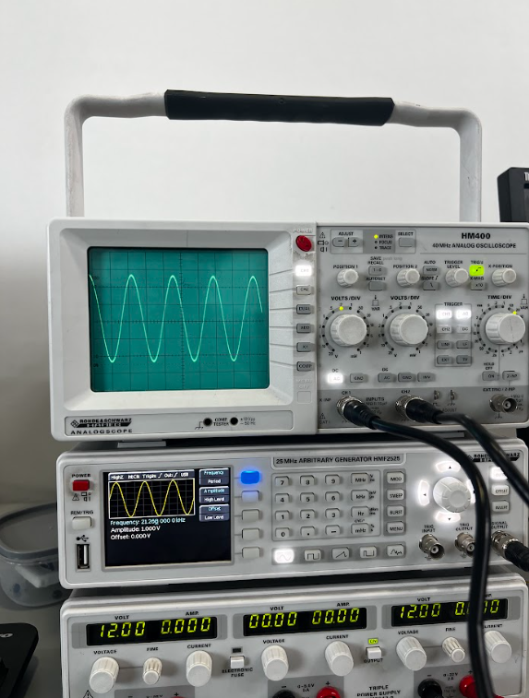Channel1:

Input:

Vin= 1 volt

FC=21268 Hz

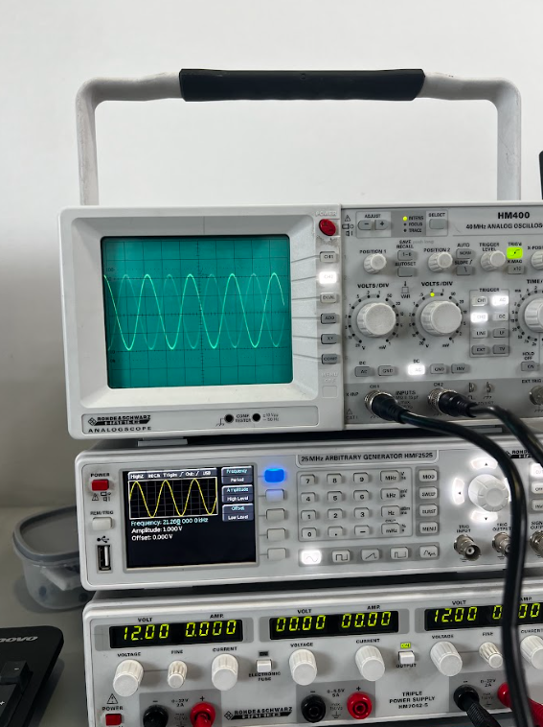Channel 2:

Output:

Vin= 1 volt

Gain=-1

FC=21268 Hz

Sin low frequency:

Gain: almost -1

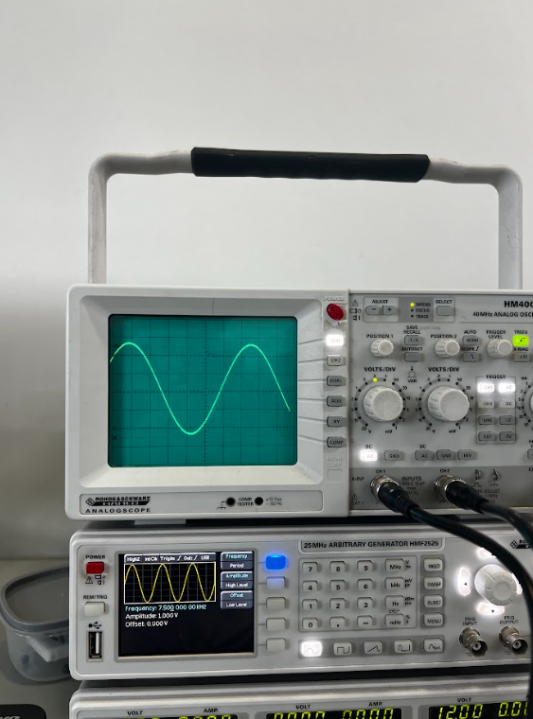Channel1:

Input:

Vin= 1 volt

FL=4500 Hz

Channel2:

Output:

Vin= 1 volt

Vout/Vin=-1

FL=4500 Hz

Sin High Frequency:

Gain: almost -0.5

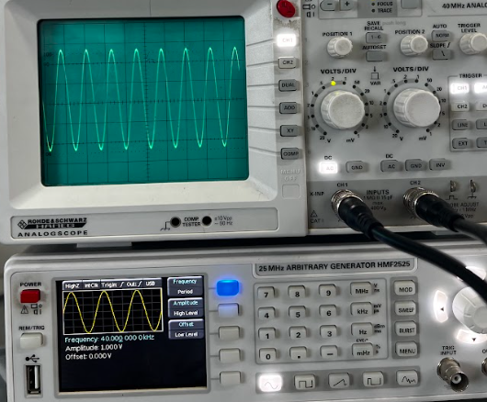Channel 1:

Vin= 1 volt

FH=40000Hz

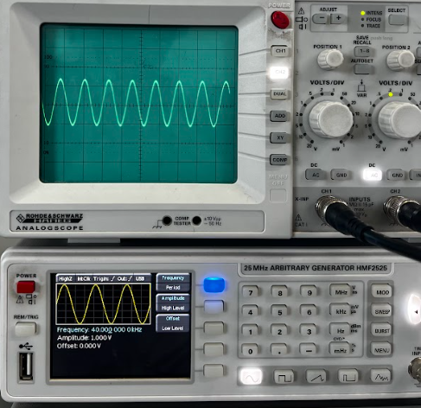Channel 2:

Vin= 1 volt

Vout/Vin=-0.5

FH=40000Hz

Hardware:

